**Googe Form**

**Nav-bar:**

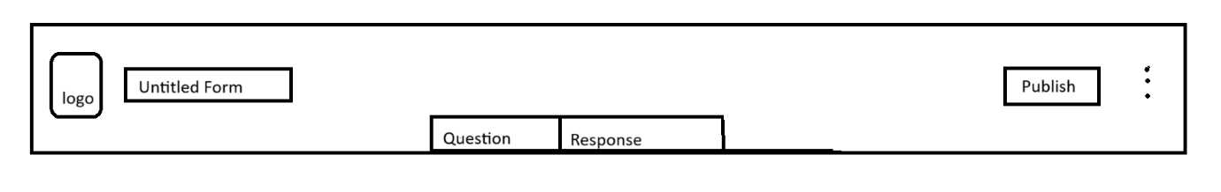

In navigation bar, it contains the logo, title of the form, publish button, settings section, pages for questions and sections.

**Title :**

Default-name: “Untitled form”

Characters: All characters are allowed.

when the publish button is clicked the form and the questions that are being entered by the user will be taken and stored in the database and from that form will be created.

Length: max- 50 char.

Tag : Input[type = text]

**Heading of the Form**

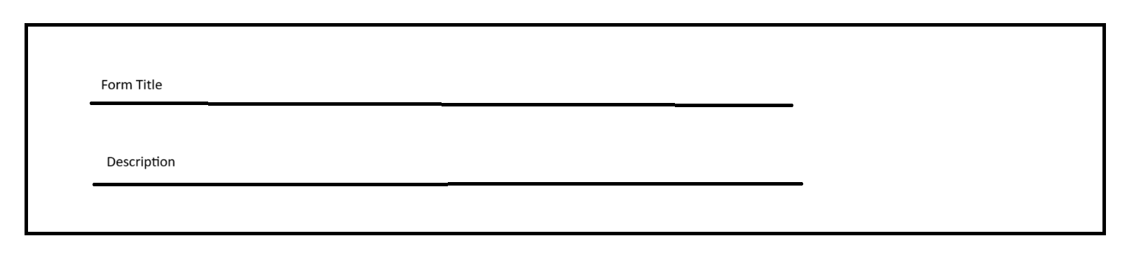

**Description :**

Placeholder : “Form description”

Default-name: “”

Characters: All characters are allowed.

Length: no limit.

Tag : Input[type = text]

**Form Title :**

Default-name: “Untitled form”

Characters: All characters are allowed.

Length: max- 50 char.

Tag : Input[type = text]

This is the heading of the form, in this, two input fields are available. So one is the form title and other one is the description about the form.

**Question container**

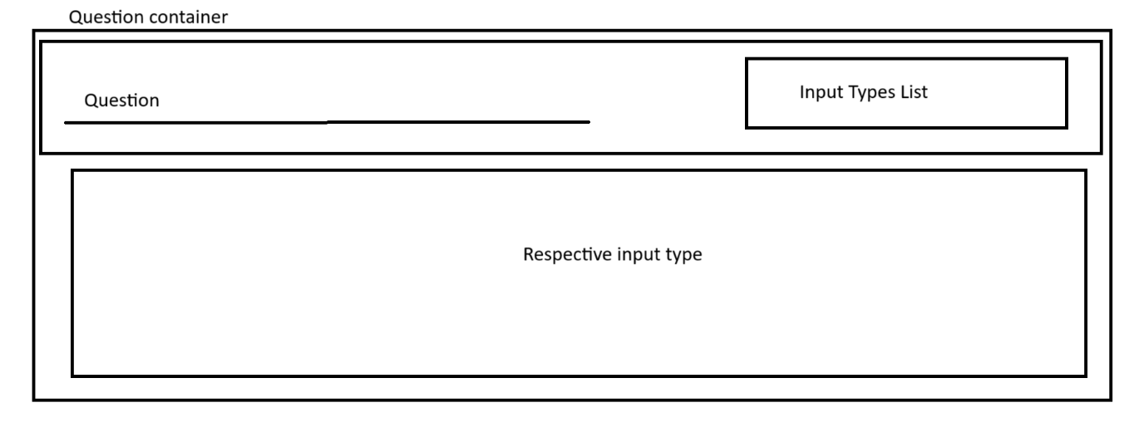

Question :

Characters: All characters are allowed.

Tag : Input[type = text]

Question container is the section where the user’s questions are entered and the questions input type is selected by near by button

**Input Type List :**

Multiple choice,

drop down,

check box,

date,

time,

paragraph.

Multiple choice, drop down, uncheck box. So these three things will be having options for a particular question. So it may be two or more options are allowed to create using add another button

**Slider**

A slider will be attached to each container, which will be having an add button and delete button. So when add button is clicked another question container will be generated and when a delete button is clicked the particular active question container will be deleted.

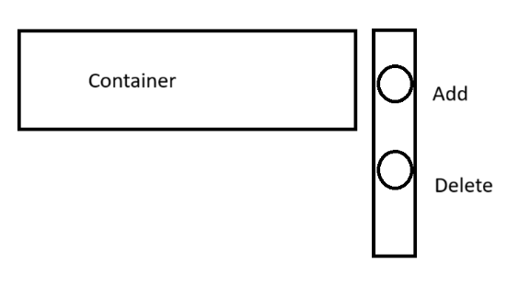

**Footer to Question container**

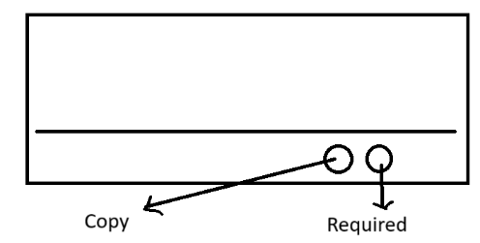

Each question container will be having an footer like section in which it has two buttons, copy button and a required button. So the copy button is to copy the question container again below it and the required button is to make the user who submits the answer to the particular question to be required and mandatory.

**Final Question generator Page**

